With a block diagram write the classification of sensors and their functions

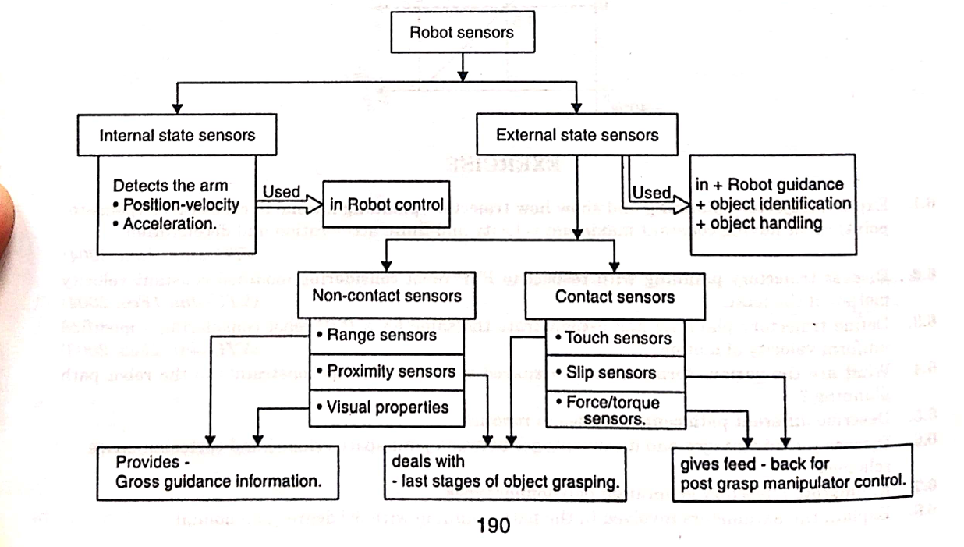

**Classification of Sensors**

1. **Robot Sensors**
   * **Internal State Sensors**
     + Detect the arm’s:
       - Position-Velocity
       - Acceleration
     + **Function**: Used in Robot Control.
   * **External State Sensors**
     + **Non-Contact Sensors**
       - Types:
         * Range Sensors
         * Proximity Sensors
         * Visual Properties
       - **Function**: Provides Gross Guidance Information.
     + **Contact Sensors**
       - Types:
         * Touch Sensors
         * Slip Sensors
         * Force/Torque Sensors
       - **Functions**:
         * Deals with Last Stages of Object Grasping.
         * Provides Feedback for Post-Grasp Manipulator Control.

**Explain proximity sensors with a neat sketch**

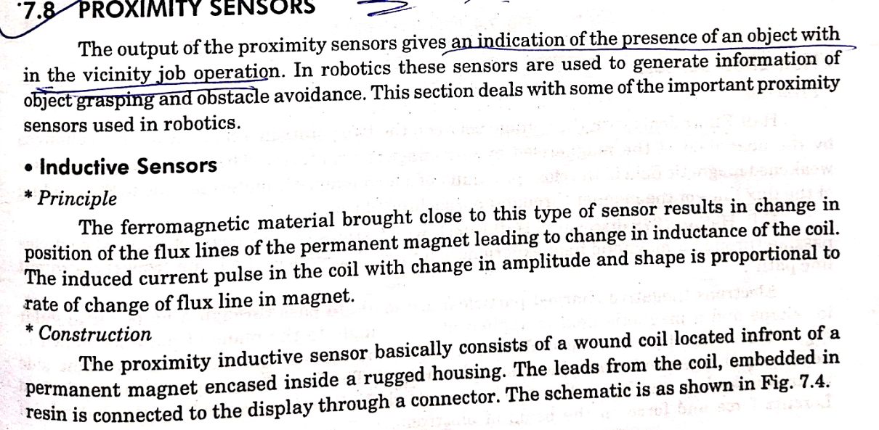

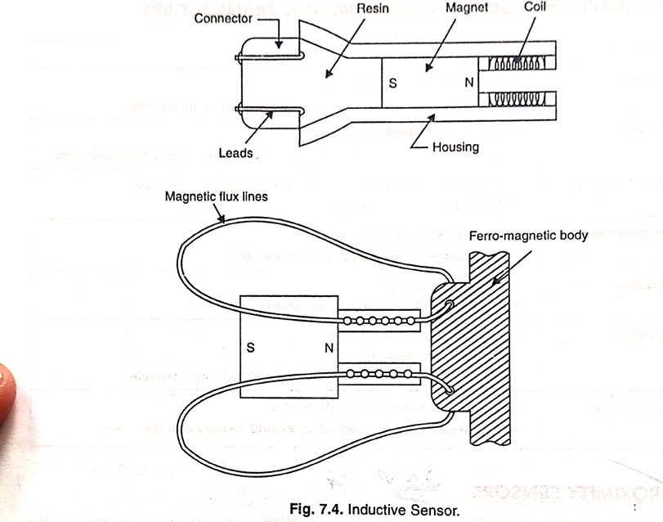

**Explain hall effect sensors with a neat sketch**

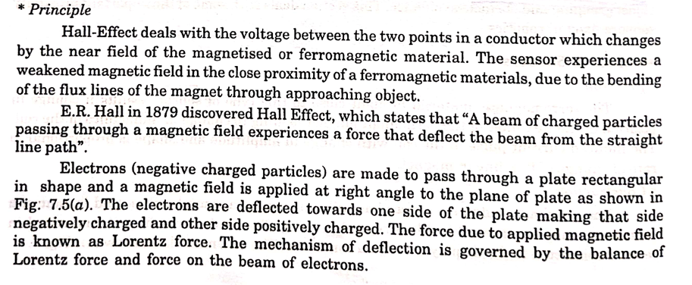

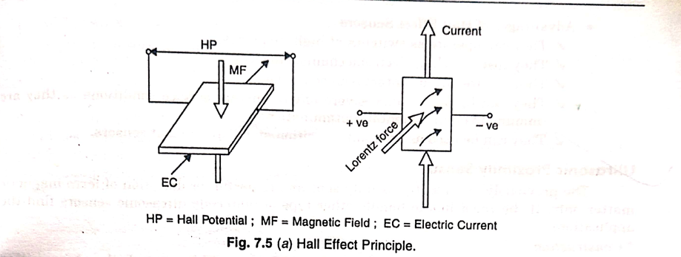

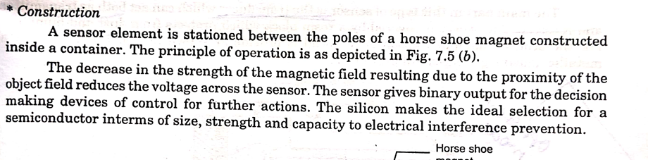

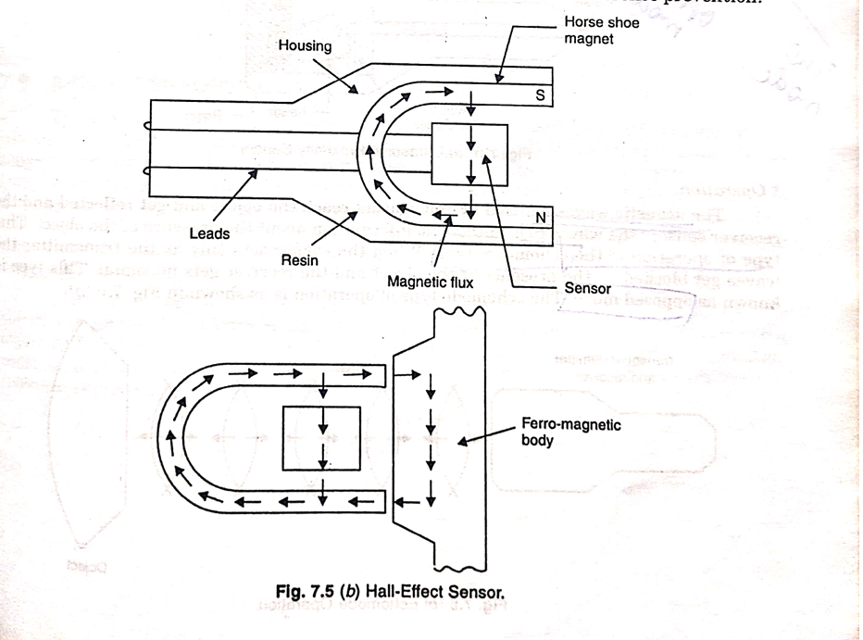

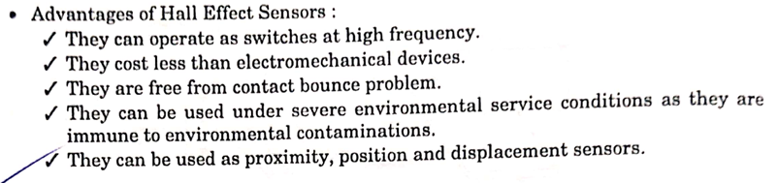

**Explain ultrasonic proximity sensors with a neat sketch**

With a block diagram explain vision system

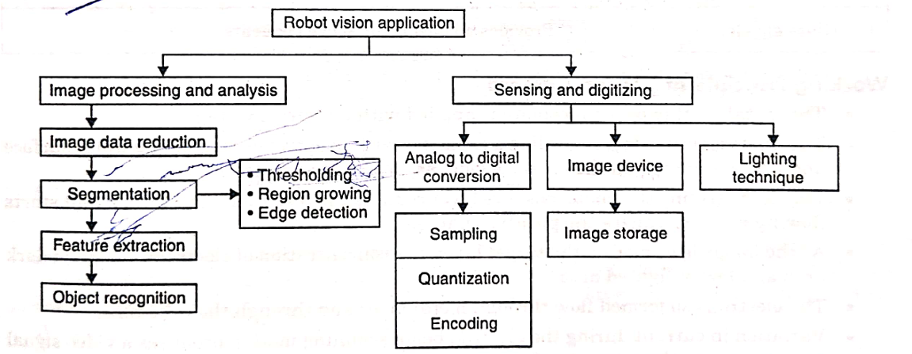

**1. Image Processing and Analysis**

This branch focuses on analyzing the captured images to extract meaningful information for decision-making.

**Steps:**

1. **Image Data Reduction:**
   * Reducing the amount of data in an image while retaining essential details. This prepares the image for further processing.
2. **Segmentation:**
   * Dividing the image into distinct regions or objects for focused analysis.
   * Techniques for segmentation include:
     + **Thresholding:** Separating objects based on pixel intensity levels.
     + **Region Growing:** Grouping neighboring pixels with similar properties.
     + **Edge Detection:** Identifying boundaries of objects in the image.
3. **Feature Extraction:**
   * Extracting specific features (e.g., shape, texture, or color) from the segmented regions for further analysis or recognition.
4. **Object Recognition:**
   * Identifying and classifying objects in the image based on the extracted features.

**2. Sensing and Digitizing**

This branch involves capturing the visual data and converting it into a digital format that can be processed.

**Steps:**

1. **Analog to Digital Conversion:**
   * **Sampling:** Capturing image data at discrete intervals.
   * **Quantization:** Mapping the sampled data into discrete intensity levels.
   * **Encoding:** Representing the data in a format suitable for digital storage or processing.
2. **Image Device:**
   * Refers to the hardware used for image capture (e.g., cameras or sensors).
   * **Image Storage:** Storing the captured image data for processing or future use.
3. **Lighting Technique:**
   * Ensures proper illumination of the scene for accurate image capture and processing.
   * Good lighting is critical for reducing noise and enhancing the clarity of the image.

**What is image storage explain image processing and analysis in detail**

**What do u understand by the term robot vision explain its principal functions And functional description in detail**

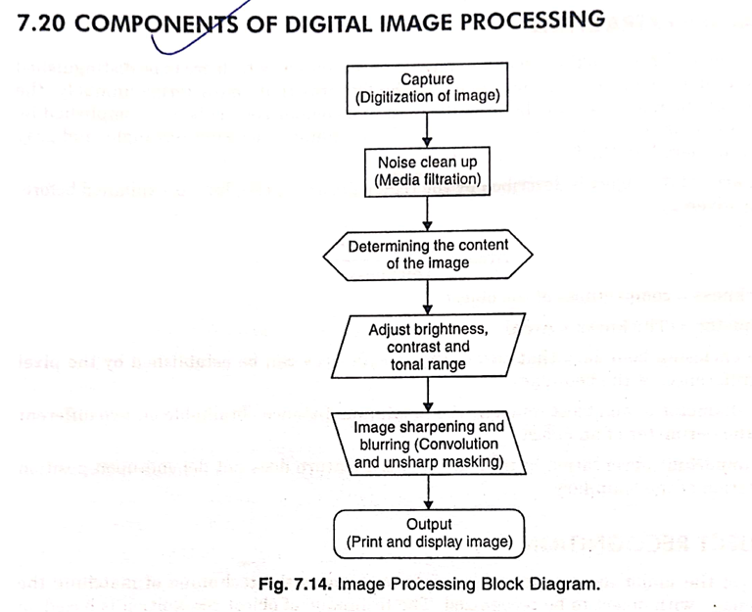

**Components of Digital Image Processing**

1. **Capture (Digitization of Image):**
   * This is the first step where an analog image is captured and converted into a digital form using sensors and digitization techniques.
   * The image is stored as a grid of pixels, each representing a specific intensity or color.
2. **Noise Clean-Up (Media Filtration):**
   * Removes unwanted distortions or noise from the image to improve its quality.
   * Techniques such as **median filtering**, **Gaussian filtering**, or other noise-reduction methods are used to smooth the image.
3. **Determining the Content of the Image:**
   * This step involves analyzing the image to identify and define its contents.
   * May include segmentation, edge detection, or feature extraction to prepare the image for further processing.
4. **Adjust Brightness, Contrast, and Tonal Range:**
   * Enhances the visual quality of the image by modifying its brightness, contrast, and tonal properties.
   * Techniques include histogram equalization or gamma correction to balance the image’s lighting conditions.
5. **Image Sharpening and Blurring:**
   * **Sharpening:** Improves the clarity of edges and details in the image. Common methods include convolution with sharpening kernels.
   * **Blurring:** Smoothens the image by reducing sharp changes in intensity. Often used for noise reduction or artistic effects.
   * Techniques like **unsharp masking** or **convolution filtering** are applied.
6. **Output (Print and Display Image):**
   * The processed image is then prepared for display or printing.
   * The output can be used in applications such as medical imaging, object recognition, or computer vision.

**Purpose of Each Component:**

* **Capture:** Converts real-world images into a digital format for processing.
* **Noise Clean-Up:** Improves the quality of the raw image.
* **Content Analysis:** Prepares the image for further specific tasks, like classification or object detection.
* **Enhancements:** Improves visual appeal and usability.
* **Output:** Ensures the processed image meets the application’s requirements.